Переклад з української мови на англійську мову
Translation from Ukrainian into English

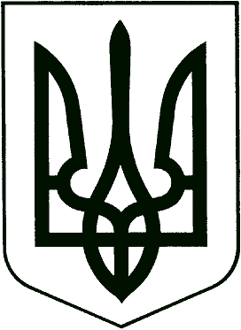

UKRAINE

master’s
DEGREE DIPLOMA

A No. 439079
Derzhznak. Ukraine Printing Company. Order 0-3104, 2010, I quarter

CK No. 41190808 | DIPLOMA  Shcherbakova  Larysa Oleksandrivna  graduated in 2011 from Odesa State Academy of Refrigeration and obtained complete higher education majoring in “Design Information Technologies” and is qualified as System Programmer.  Rector /signature/ V. V. Prytula  June 30, 2011  Official Seal:  Ministry of Education and Science of Ukraine* 02071085* Odesa State Academy of Refrigeration*

